

Semester Two Examination, 2018

Question/Answer booklet

MATHEMATICS METHODS
UNIT 1 AND 2

Section One:

Calculator-free

Name: _______________________________________________________

Teacher’s Name:_______________________________________________

Time allowed for this section
Reading time before commencing work: five minutes
Working time: fifty minutes

Materials required/recommended for this section
To be provided by the supervisor
This Question/Answer booklet
Formula sheet

To be provided by the candidate
Standard items: pens (blue/black preferred), pencils (including coloured), sharpener, correction fluid/tape, eraser, ruler, highlighters

Special items: nil

Important note to candidates
No other items may be taken into the examination room. It is your responsibility to ensure that you do not have any unauthorised material. If you have any unauthorised material with you, hand it to the supervisor before reading any further.
Question | Marks
1
2
3
4
5
6
TOTAL

Structure of this paper

Section | Number of questions available | Number of questions to be answered | Working time (minutes) | Marks available | Percentage of examination
Section One:  Calculator-free | 6 | 6 | 50 | 50 | 33
Section Two:  Calculator-assumed | 9 | 9 | 100 | 100 | 67
 |  |  |  | Total | 100

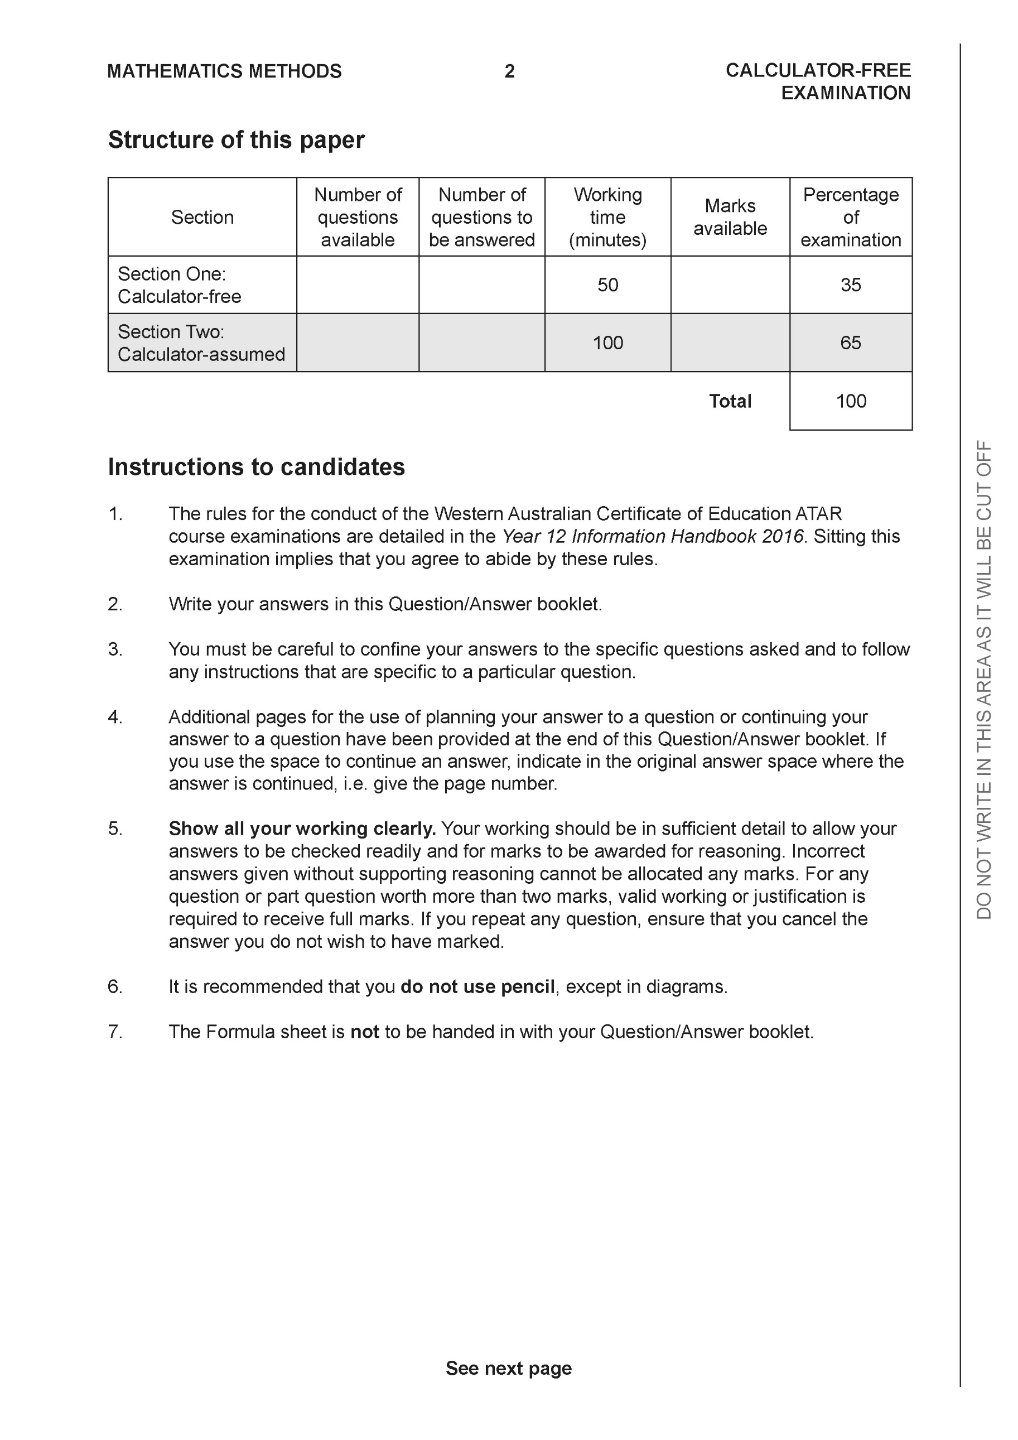

Section One: Calculator-free (50 Marks)

This section has six (6) questions. Answer all questions. Write your answers in the spaces provided.

Spare pages are included at the end of this booklet. They can be used for planning your responses and/or as additional space if required to continue an answer.
● Planning: If you use the spare pages for planning, indicate this clearly at the top of the page.
● Continuing an answer: If you need to use the space to continue an answer, indicate in the original answer space where the answer is continued, i.e. give the page number. Fill in the number of the question that you are continuing to answer at the top of the page.

Working time: 50 minutes.

Question 1 ( 5 marks)
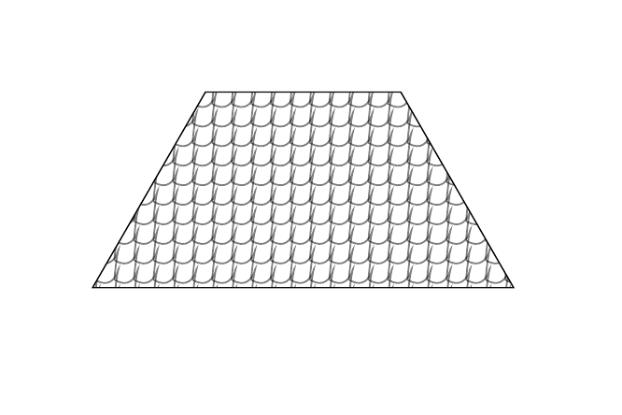
The roof of a heritage building has roof tiles arranged neatly in horizontal rows. A sample diagram is shown below.

There are 28 roof tiles in the top row and each consecutive row has an extra 4 tiles than the row above it. If the bottom row has 96 tiles, show that there is a total of 1116 tiles on the roof of the museum.

Question 2 ( 4 marks)
Evaluate the expression below, giving your answer as a simplified fraction.

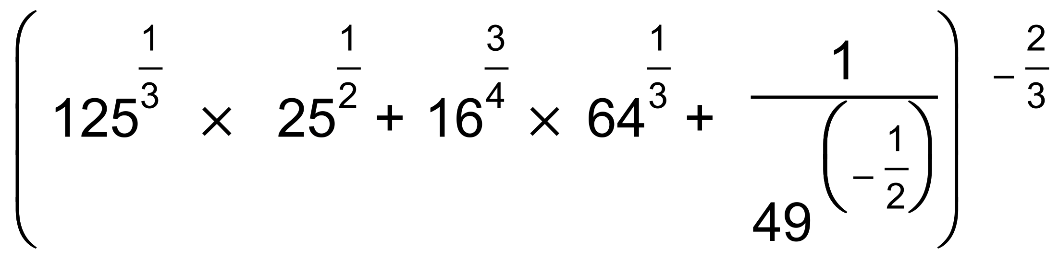

Question 3 (11 marks)

Given the function $f\left(x\right)=2x^{2}-6x-10,$

(a) state $f\left(x+h\right)$. Do not simplify. (2 marks)

(b) set up and evaluate the difference quotient to find the derivative of the function.
(4 marks)

(c) What is the instantaneous rate of change when $x=-2?$ (2 marks)

(d) Is the rate of change increasing or decreasing for $x<-2?$ Justify. (3 marks)

Question 4 ( 7 marks)

Given the equation $2^{x+1}+2^{3-x}=17, x ∈ R,$

(a) use a suitable substitution to rewrite the equation above as a quadratic equation,
(3 marks)

(b) hence, determine the solution(s) to the exponential equation. (4 marks)

Question 5 (11 marks)

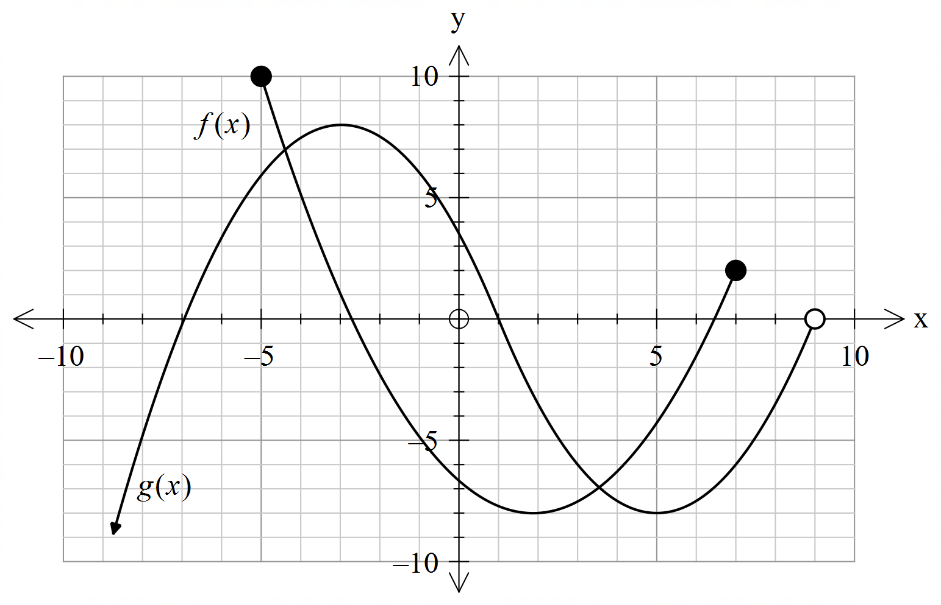The graphs of the functions and are shown below.



(a) State the domain of $g(x)$. (1 mark)

(b) State the range of $f(x)$. (1 mark)

(c) Which function(s), if any, have a point of inflection? (1 mark)

(d) Describe how the graph of may be obtained from the graph of and hence state the coordinates of the turning point(s) of the graph. (3 marks)

(e) Describe how the graph of may be obtained from the graph of and hence state the coordinates of the endpoints of the graph. (3 marks)

(f) State the approximate solution(s) to the equation . (2 marks)

Question 6 (12 marks)

Given the following equations:
$$y_{1}=2\cos{2x}, y_{2}=3\tan{2x}, 0≤x≤2π.$$

- Sketch on a single set of axes the graph of $y_{1}$ and $y_{2}$ . (4 marks)
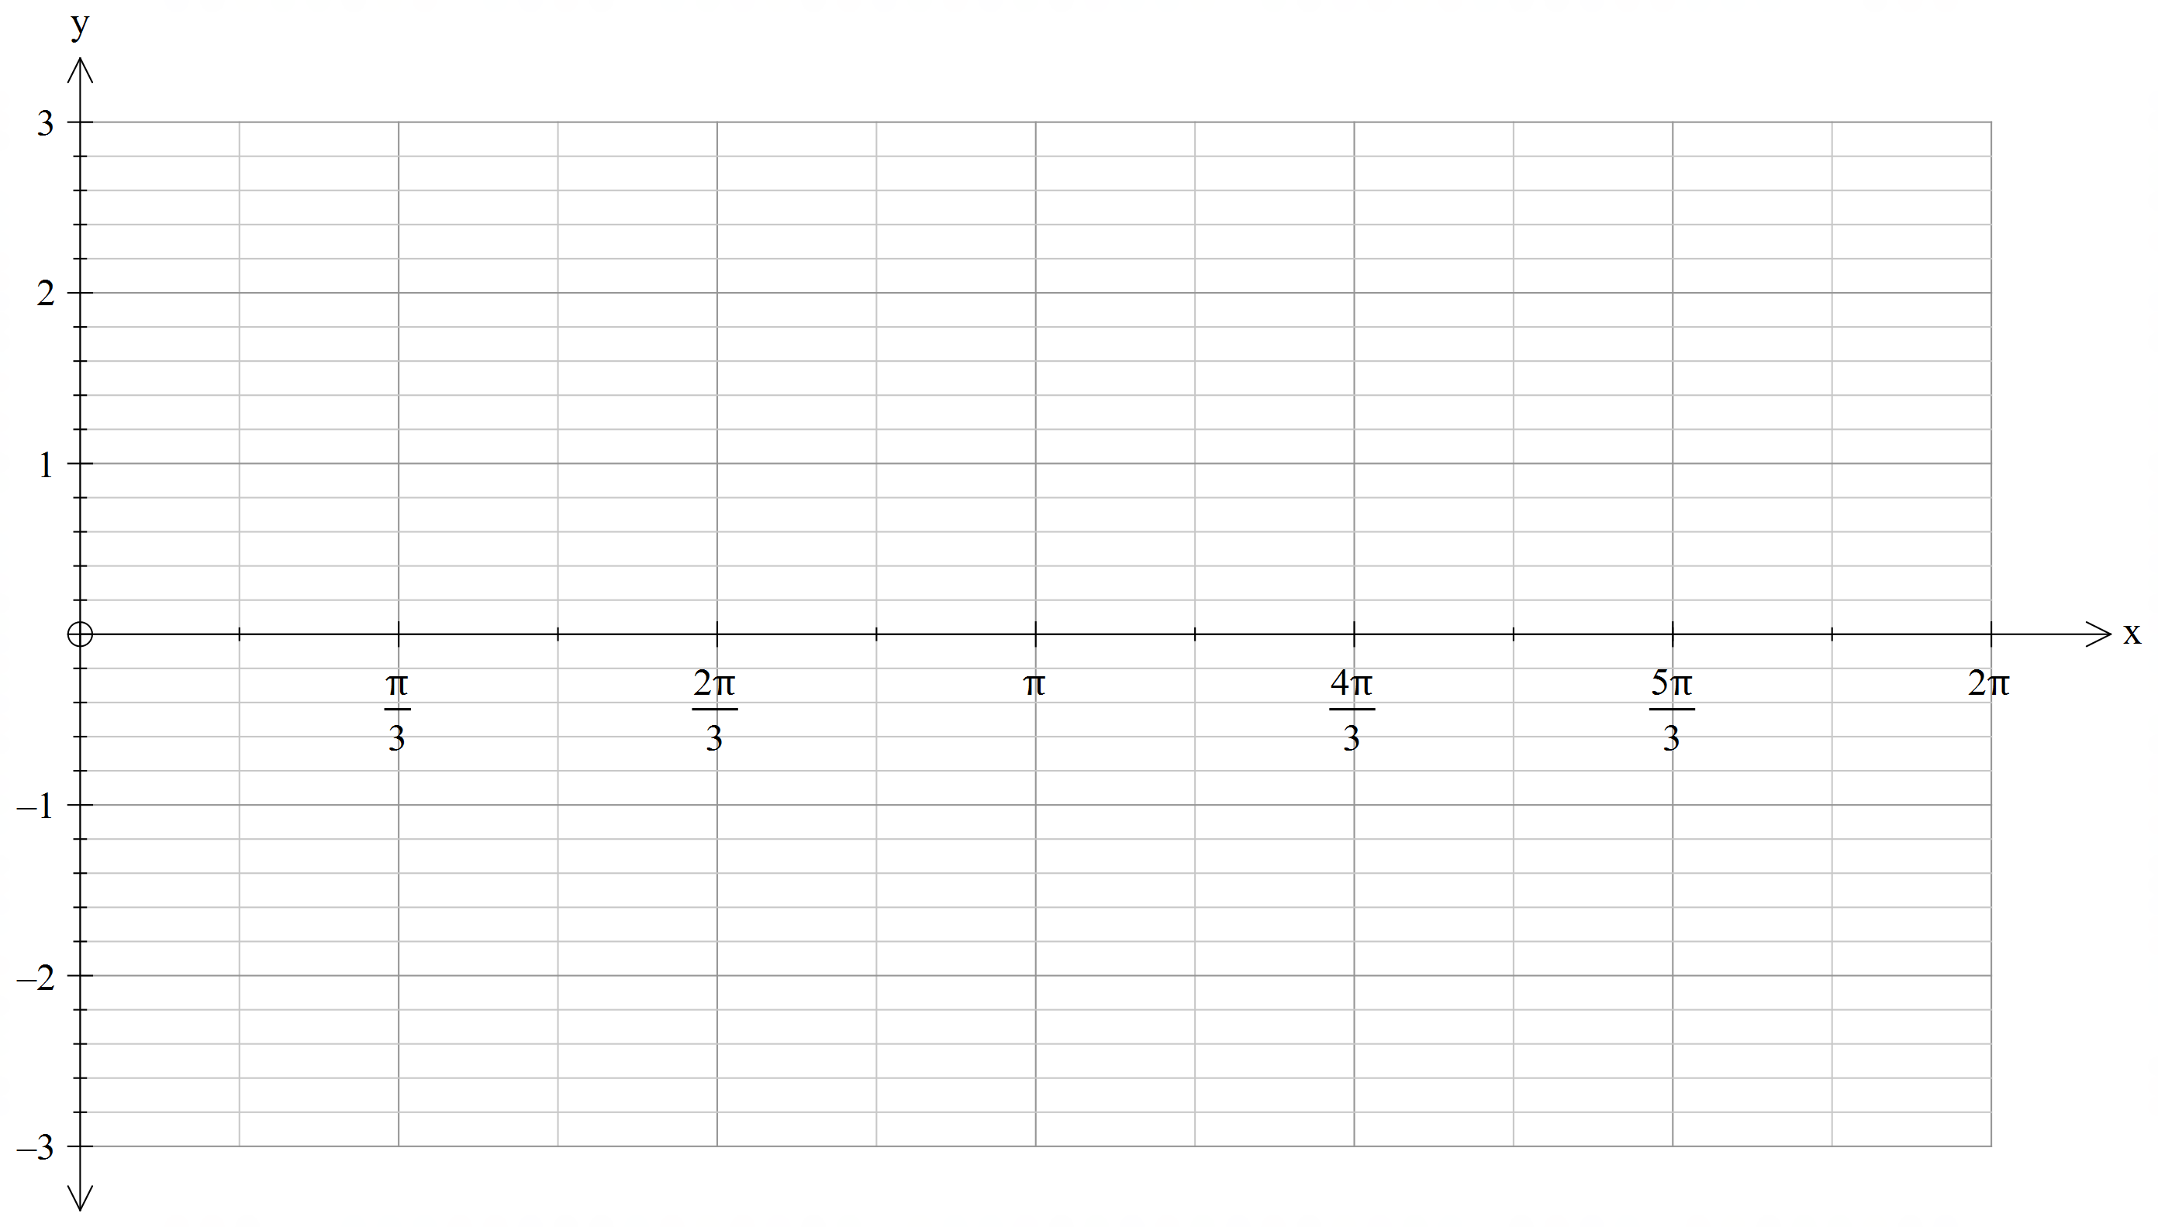

- Show that the coordinates of the points of intersections between the graphs of $y_{1}$and $y_{2}$ are solutions of the equation $2\sin^{2}{2x+3\sin{2x-2=0.}}$ (3 marks)

(b) Show that the coordinates of the points of intersection between the graphs of $y_{1}$ and $y_{2}$ are solutions of the equation $2\sin^{2}{2x+3\sin{2x}-2=0.}$ (4 marks)

(c) Hence find the $x$ coordinates of the points of intersection between the graphs of $y_{1}$ and
$y_{2}$ over the domain $[0,2π]$. (4 marks)

END OF SECTION 1
Additional working space
Question number:

Additional working space
Question number:

Additional working space
Question number:

Additional working space
Question number:

